PROJECT REQUIREMENT SPECIFICATION & DESIGN DOCUMENT
Phone Book Management System
Version 1.0
Document Information
Project Name: Phone Book Management System
Document Type: Requirement Specification & Design Document
Version: 1.0
Date: 05/01/2026
Prepared by: Group 06

Revision History
Date | Version | Description | Author
05/01/2026 | 1.0 | Initial version created | Group 06
15/01/2026

1. SPECIFIC REQUIREMENTS

1.1 Functional Requirements (FR)
FR-01 View Contact List
Users can view all contacts stored in the system.
• Inputs: None
• Outputs: List of contacts
• Pre-condition: System is running
• Post-condition: Contacts displayed on UI
FR-02 View Contact Detail
User can select a contact to view detailed information.
• Inputs: Selected contact
• Outputs: Contact detail screen
• Pre-condition: Contact exists
• Post-condition: Contact details displayed
FR-03 Add Contact
User can add a new contact with required fields (full name, phone number). Optional: email, address, note, group(s).
• Validation: Phone not empty; unique phone; valid email if provided.
• Outputs: Contact added confirmation
• Pre-condition: System running
• Post-condition: New contact stored
FR-04 Update Contact
User can update an existing contact. Validation same as Add Contact.
• Outputs: Contact updated confirmation
• Pre-condition: Contact exists
• Post-condition: Contact updated in storage
FR-05 Delete Contact
User can delete a contact permanently. System must request confirmation before deleting.
• Outputs: Contact deleted confirmation
• Pre-condition: Contact exists
• Post-condition: Contact removed
FR-06 Mark/Unmark Favorite
User can mark a contact as favorite and remove it from favorite list.
• Outputs: Favorite status updated
• Pre-condition: Contact exists
• Post-condition: Favorite flag updated
FR-07 Search Contact
User can search contacts by keyword (name, phone number, email).
• Inputs: Keyword
• Outputs: Search result list
• Pre-condition: Contacts exist
• Post-condition: Results displayed
FR-08 Filter By Group
User can filter contacts by group.
• Inputs: Selected group
• Outputs: Filtered list
• Pre-condition: Group exists
• Post-condition: Filtered results displayed
FR-09 Sort Contact List
User can sort contact list by name (A-Z/Z-A), created date, updated date.
• Inputs: Sort option
• Outputs: Sorted list
• Pre-condition: List displayed
• Post-condition: List reordered
FR-10 Create Group
User can create a new group. Validation: Group name must be unique.
• Inputs: Group name
• Outputs: Group created confirmation
• Pre-condition: System running
• Post-condition: Group stored
FR-11 Update Group
User can rename or update group description.
• Inputs: Group info
• Outputs: Group updated confirmation
• Pre-condition: Group exists
• Post-condition: Group updated
FR-12 Delete Group
User can delete a group. Contacts remain, only group relation removed.
• Inputs: Selected group
• Outputs: Group deleted confirmation
• Pre-condition: Group exists
• Post-condition: Group removed
FR-13 Assign Contact to Group
User can assign a contact into one or more groups.
• Inputs: Contact + group(s)
• Outputs: Assignment confirmation
• Pre-condition: Contact & group exist
• Post-condition: Relationship stored
FR-14 Remove Contact from Group
User can remove a contact from a group.
• Inputs: Contact + group
• Outputs: Removal confirmation
• Pre-condition: Relationship exists
• Post-condition: Relationship removed
FR-15 Import Contacts
User can import contacts from CSV/Excel. System validates each record; invalid records are skipped and reported; duplicates handled by chosen policy.
• Inputs: CSV/Excel file
• Outputs: Import summary
• Pre-condition: File provided
• Post-condition: Contacts imported
FR-16 Export Contacts
User can export contacts to CSV/Excel. Export scope: all, by group, or by search results.
• Inputs: Format + scope
• Outputs: Export file
• Pre-condition: Contacts exist
• Post-condition: File generated

2. NON-FUNCTIONAL REQUIREMENTS (NFR)
NFR-01 Usability
UI must be easy to understand for first-time users. CRUD operations must be completed within 3 steps. Error messages must be clear and user-friendly.
NFR-02 Performance
Searching within 10,000 contacts must complete in ≤ 2 seconds. CRUD operations must respond in ≤ 1 second.
NFR-03 Reliability
System must not lose data during normal operations and must ensure consistent storage.
NFR-04 Security
If multi-user login exists: Password stored in hashed form; Users can only access their own contact list.
NFR-05 Maintainability
The system must follow modular architecture (MVC/Layered). Code must be readable and well-documented.
NFR-06 Portability
System should run on Windows at minimum. Database should be portable (SQLite recommended).

3. SYSTEM MODELS (DIAGRAMS)
IMPORTANT: In this section, insert screenshots from diagrams.net (draw.io).

3.1 Data Flow Diagram (DFD)

3.1.1 DFD Level 0 (Context Diagram)
Actors: User. System: Phone Book Management System. Data flows: Manage contacts, manage groups, search/filter, import/export.
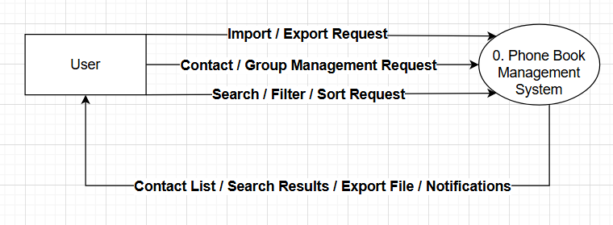DFD LEVEL 0 IMAGE

3.1.2 DFD Level 1
Processes: P1 Manage Contacts, P2 Manage Groups, P3 Search & Filter, P4 Import/Export. Data Stores: D1 Contact Database, D2 Group Database.
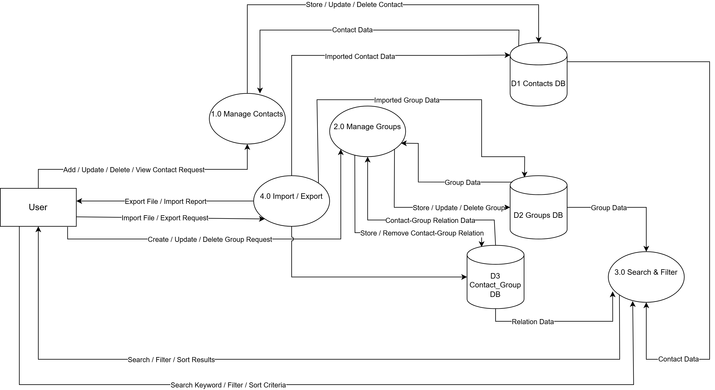
DFD LEVEL 1 IMAGE

4.2 USE CASE DIAGRAM
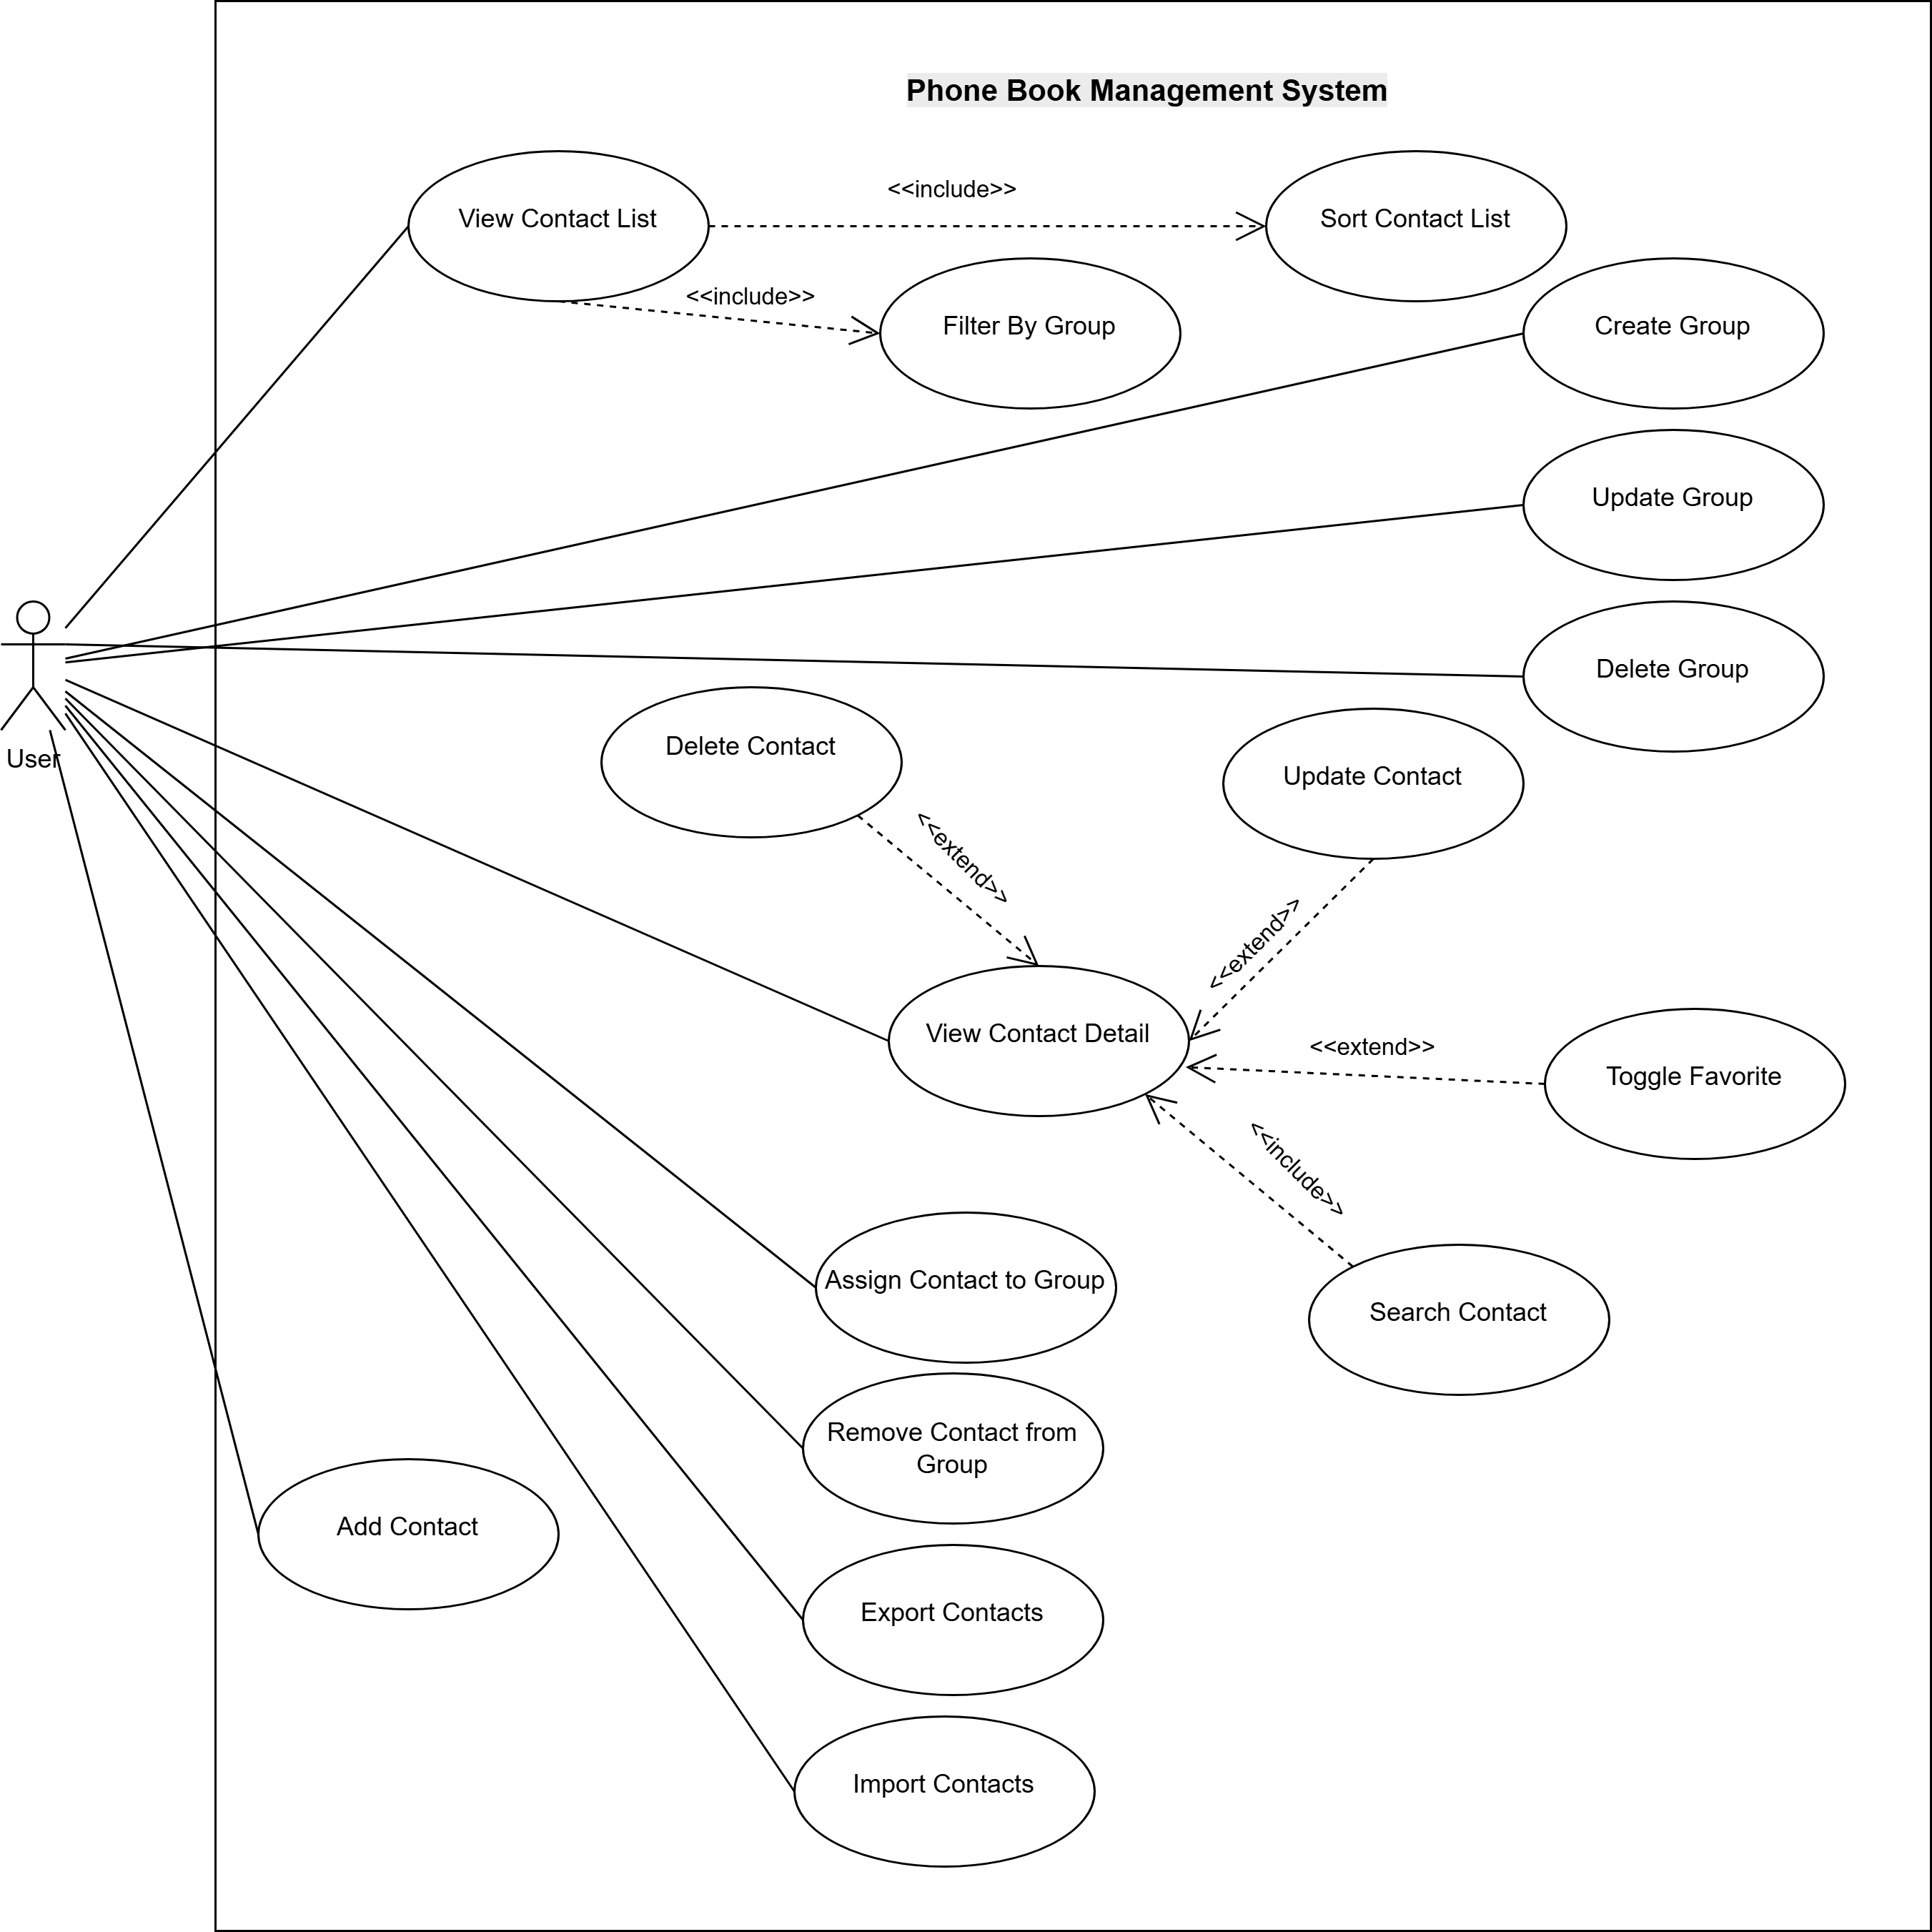
The following actors and use cases are identified.
Actor(s):
Number | Use-Case | Meaning
1 | User | The User is the person who interacts with the Phone Book Management System to manage contacts and groups, search/filter/sort data, and import/export contacts.

Use Cases:
No. | Use Case | Meaning
1 | View Contact List | Displays all saved contacts in the system.
2 | View Contact Detail | Shows detailed information of a selected contact.
3 | Add Contact | Creates a new contact with required information.
4 | Update Contact | Modifies information of an existing contact.
5 | Delete Contact | Removes a contact from the system.
6 | Search Contact | Finds contacts using keyword (name/phone/email).
7 | Filter By Group | Shows contacts that belong to a selected group.
8 | Sort Contact List | Sorts the contact list by selected criteria (e.g., name).
9 | Toggle Favorite | Marks or unmarks a contact as favorite.
10 | Create Group | Creates a new contact group/category.
11 | Update Group | Updates information of an existing group.
12 | Delete Group | Deletes a group from the system.
13 | Assign Contact to Group | Adds a contact into one or more groups.
14 | Remove Contact from Group | Removes a contact from a group.
15 | Import Contacts | Imports contacts from an external file (CSV/Excel).
16 | Export Contacts | Exports contacts to an external file (CSV/Excel).

4.2.1. UC-01 – View Contact List
Summary:
This use case allows the user to view all contacts in the Phone Book Management System.
Primary Actor:
User
Preconditions:
- The system is running normally.
Postconditions:
- The requested operation is completed successfully.
Main Flow:
1. User selects the corresponding function.
2. System processes the request.
3. System updates the database if needed.
4. System displays the result to the user.
Alternative Flows:
- A1: Invalid input → System shows error message.
- A2: System error → System shows failure notification.
Special Requirements:
- Response time should be within acceptable limits.
Extension Points:
- None.

4.2.2. UC-02 – View Contact Detail
Summary:
This use case allows the user to view detailed information of a contact in the Phone Book Management System.
Primary Actor:
User
Preconditions:
- The system is running normally.
Postconditions:
- The requested operation is completed successfully.
Main Flow:
1. User selects the corresponding function.
2. System processes the request.
3. System updates the database if needed.
4. System displays the result to the user.
Alternative Flows:
- A1: Invalid input → System shows error message.
- A2: System error → System shows failure notification.
Special Requirements:
- Response time should be within acceptable limits.
Extension Points:
- None.

4.2.3. UC-03 – Add Contact
Summary:
This use case allows the user to add a new contact in the Phone Book Management System.
Primary Actor:
User
Preconditions:
- The system is running normally.
Postconditions:
- The requested operation is completed successfully.
Main Flow:
1. User selects the corresponding function.
2. System processes the request.
3. System updates the database if needed.
4. System displays the result to the user.
Alternative Flows:
- A1: Invalid input → System shows error message.
- A2: System error → System shows failure notification.
Special Requirements:
- Response time should be within acceptable limits.
Extension Points:
- None.

4.2.4. UC-04 – Update Contact
Summary:
This use case allows the user to update an existing contact in the Phone Book Management System.
Primary Actor:
User
Preconditions:
- The system is running normally.
Postconditions:
- The requested operation is completed successfully.
Main Flow:
1. User selects the corresponding function.
2. System processes the request.
3. System updates the database if needed.
4. System displays the result to the user.
Alternative Flows:
- A1: Invalid input → System shows error message.
- A2: System error → System shows failure notification.
Special Requirements:
- Response time should be within acceptable limits.
Extension Points:
- None.

4.2.5. UC-05 – Delete Contact
Summary:
This use case allows the user to delete a contact in the Phone Book Management System.
Primary Actor:
User
Preconditions:
- The system is running normally.
Postconditions:
- The requested operation is completed successfully.
Main Flow:
1. User selects the corresponding function.
2. System processes the request.
3. System updates the database if needed.
4. System displays the result to the user.
Alternative Flows:
- A1: Invalid input → System shows error message.
- A2: System error → System shows failure notification.
Special Requirements:
- Response time should be within acceptable limits.
Extension Points:
- None.

4.2.6. UC-06 – Search Contact
Summary:
This use case allows the user to search contacts by keyword in the Phone Book Management System.
Primary Actor:
User
Preconditions:
- The system is running normally.
Postconditions:
- The requested operation is completed successfully.
Main Flow:
1. User selects the corresponding function.
2. System processes the request.
3. System updates the database if needed.
4. System displays the result to the user.
Alternative Flows:
- A1: Invalid input → System shows error message.
- A2: System error → System shows failure notification.
Special Requirements:
- Response time should be within acceptable limits.
Extension Points:
- None.

4.2.7. UC-07 – Filter By Group
Summary:
This use case allows the user to filter contacts by group in the Phone Book Management System.
Primary Actor:
User
Preconditions:
- The system is running normally.
Postconditions:
- The requested operation is completed successfully.
Main Flow:
1. User selects the corresponding function.
2. System processes the request.
3. System updates the database if needed.
4. System displays the result to the user.
Alternative Flows:
- A1: Invalid input → System shows error message.
- A2: System error → System shows failure notification.
Special Requirements:
- Response time should be within acceptable limits.
Extension Points:
- None.

4.2.8. UC-08 – Sort Contact List
Summary:
This use case allows the user to sort contacts in the Phone Book Management System.
Primary Actor:
User
Preconditions:
- The system is running normally.
Postconditions:
- The requested operation is completed successfully.
Main Flow:
1. User selects the corresponding function.
2. System processes the request.
3. System updates the database if needed.
4. System displays the result to the user.
Alternative Flows:
- A1: Invalid input → System shows error message.
- A2: System error → System shows failure notification.
Special Requirements:
- Response time should be within acceptable limits.
Extension Points:
- None.

4.2.9. UC-09 – Toggle Favorite
Summary:
This use case allows the user to mark or unmark favorite in the Phone Book Management System.
Primary Actor:
User
Preconditions:
- The system is running normally.
Postconditions:
- The requested operation is completed successfully.
Main Flow:
1. User selects the corresponding function.
2. System processes the request.
3. System updates the database if needed.
4. System displays the result to the user.
Alternative Flows:
- A1: Invalid input → System shows error message.
- A2: System error → System shows failure notification.
Special Requirements:
- Response time should be within acceptable limits.
Extension Points:
- None.

4.2.10. UC-10 – Create Group
Summary:
This use case allows the user to create a group in the Phone Book Management System.
Primary Actor:
User
Preconditions:
- The system is running normally.
Postconditions:
- The requested operation is completed successfully.
Main Flow:
1. User selects the corresponding function.
2. System processes the request.
3. System updates the database if needed.
4. System displays the result to the user.
Alternative Flows:
- A1: Invalid input → System shows error message.
- A2: System error → System shows failure notification.
Special Requirements:
- Response time should be within acceptable limits.
Extension Points:
- None.

4.2.11. UC-11 – Update Group
Summary:
This use case allows the user to update group information in the Phone Book Management System.
Primary Actor:
User
Preconditions:
- The system is running normally.
Postconditions:
- The requested operation is completed successfully.
Main Flow:
1. User selects the corresponding function.
2. System processes the request.
3. System updates the database if needed.
4. System displays the result to the user.
Alternative Flows:
- A1: Invalid input → System shows error message.
- A2: System error → System shows failure notification.
Special Requirements:
- Response time should be within acceptable limits.
Extension Points:
- None.

4.2.12. UC-12 – Delete Group
Summary:
This use case allows the user to delete a group in the Phone Book Management System.
Primary Actor:
User
Preconditions:
- The system is running normally.
Postconditions:
- The requested operation is completed successfully.
Main Flow:
1. User selects the corresponding function.
2. System processes the request.
3. System updates the database if needed.
4. System displays the result to the user.
Alternative Flows:
- A1: Invalid input → System shows error message.
- A2: System error → System shows failure notification.
Special Requirements:
- Response time should be within acceptable limits.
Extension Points:
- None.

4.2.13. UC-13 – Assign Contact to Group
Summary:
This use case allows the user to assign contact to group in the Phone Book Management System.
Primary Actor:
User
Preconditions:
- The system is running normally.
Postconditions:
- The requested operation is completed successfully.
Main Flow:
1. User selects the corresponding function.
2. System processes the request.
3. System updates the database if needed.
4. System displays the result to the user.
Alternative Flows:
- A1: Invalid input → System shows error message.
- A2: System error → System shows failure notification.
Special Requirements:
- Response time should be within acceptable limits.
Extension Points:
- None.

4.2.14. UC-14 – Remove Contact from Group
Summary:
This use case allows the user to remove contact from group in the Phone Book Management System.
Primary Actor:
User
Preconditions:
- The system is running normally.
Postconditions:
- The requested operation is completed successfully.
Main Flow:
1. User selects the corresponding function.
2. System processes the request.
3. System updates the database if needed.
4. System displays the result to the user.
Alternative Flows:
- A1: Invalid input → System shows error message.
- A2: System error → System shows failure notification.
Special Requirements:
- Response time should be within acceptable limits.
Extension Points:
- None.

4.2.15. UC-15 – Import Contacts
Summary:
This use case allows the user to import contacts from file in the Phone Book Management System.
Primary Actor:
User
Preconditions:
- The system is running normally.
Postconditions:
- The requested operation is completed successfully.
Main Flow:
1. User selects the corresponding function.
2. System processes the request.
3. System updates the database if needed.
4. System displays the result to the user.
Alternative Flows:
- A1: Invalid input → System shows error message.
- A2: System error → System shows failure notification.
Special Requirements:
- Response time should be within acceptable limits.
Extension Points:
- None.

4.2.16. UC-16 – Export Contacts
Summary:
This use case allows the user to export contacts to file in the Phone Book Management System.
Primary Actor:
User
Preconditions:
- The system is running normally.
Postconditions:
- The requested operation is completed successfully.
Main Flow:
1. User selects the corresponding function.
2. System processes the request.
3. System updates the database if needed.
4. System displays the result to the user.
Alternative Flows:
- A1: Invalid input → System shows error message.
- A2: System error → System shows failure notification.
Special Requirements:
- Response time should be within acceptable limits.
Extension Points:
- None.

5. CLASS DIAGRAM
The Class Diagram shows the structure of the system, including key classes, attributes, and relationships.

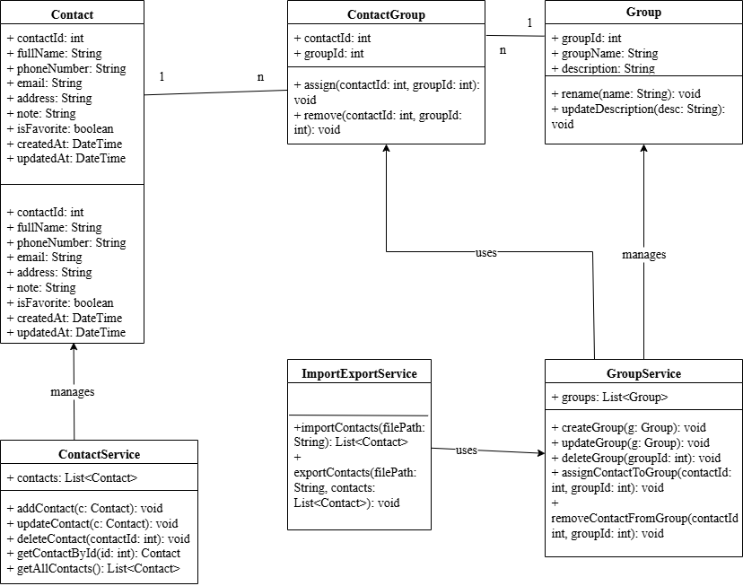

5.1 User Interface Design (UI)

5.1.1 Home Screen (Contact List)
Components: Search bar; Filter by group dropdown; Sort options; Contact list table; Buttons: Add Contact / Import / Export; Favorite section (optional).

5.1.2 Add / Update Contact Screen
Fields: Full Name (required); Phone Number (required); Email (optional); Address (optional); Note (optional); Group selection (multi-select); Favorite checkbox. Buttons: Save, Cancel.

5.1.3 Group Management Screen
Components: Group list; Create new group; Edit group; Delete group.

5.1.4 Import / Export Screen
Import: File chooser; Preview (optional); Import results summary. Export: Select format (CSV/Excel); Select scope (all/group/search results); Download file.

6. DATABASE DESIGN (DATA MODEL)

6.2.1 Entity Relationship Overview
Main entities: Contact, Group, Contact_Group (many-to-many relationship).
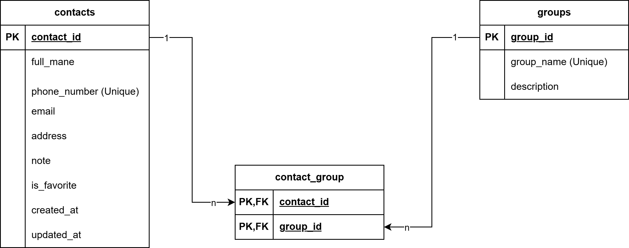ERD IMAGE

6.2.2 Database Tables
Table: contacts
Field | Type | Constraints
contact_id | INT | Primary Key, Auto Increment
full_name | VARCHAR(100) | NOT NULL
phone_number | VARCHAR(20) | NOT NULL, UNIQUE
email | VARCHAR(100) | NULL
address | VARCHAR(255) | NULL
note | TEXT | NULL
is_favorite | BOOLEAN | DEFAULT FALSE
created_at | DATETIME | DEFAULT CURRENT_TIMESTAMP
updated_at | DATETIME | NULL
Table: groups
Field | Type | Constraints
group_id | INT | Primary Key, Auto Increment
group_name | VARCHAR(50) | NOT NULL, UNIQUE
description | VARCHAR(255) | NULL
Table: contact_group
Field | Type | Constraints
contact_id | INT | Foreign Key → contacts(contact_id)
group_id | INT | Foreign Key → groups(group_id)
(contact_id, group_id) | — | Composite Primary Key

6.2.3 Primary Key and Foreign Key Summary
• Primary Keys: contacts.contact_id, groups.group_id, contact_group(contact_id, group_id).
• Foreign Keys: contact_group.contact_id → contacts.contact_id; contact_group.group_id → groups.group_id.

6.2.4 Data Validation and Integrity Rules
This section defines validation constraints and data integrity rules to ensure consistent and reliable data storage.

